SYSTEM ARCHITECTURE CAMPUS COUPON
ITC327W | Prominent Programmers (Pty) Ltd

This document presents the four system-architecture steps for the Campus Coupon system, based on the Software Requirements Specification (SRS).

Main System Components (1ST Steps)
Component | Description / Purpose
Flutter Application | Main user interface for CUT students and authorised administrators. Provides event viewing, RSVP, wallet access, administration forms, navigation, feedback, and communication with the application/API services.
ASP.NET Web Application / API | Application and API layer that receives requests from Flutter, validates requests, applies business rules, coordinates event/RSVP/attendance/reward processes, and returns structured responses.
Supabase Authentication | Provides managed authentication and supports user identity and role-based access control.
Supabase Database | Stores persistent application data such as users, roles, events, RSVPs, attendance records, reward transactions, wallet information, and related records.
Supabase Storage | Stores event media and other application assets where required.

Users and Roles (2nd Step)
User / Role | Flutter | ASP.NET | Main Activities
CUT Student | Yes | Indirectly through API | Log in, view events, RSVP for events, view wallet and transaction history, and use eligible reward points/coupons.
Event Administrator | Yes | Indirectly through API | Create, update and publish events; view RSVP lists; verify attendance; and manage attendance-related actions.
CUT Cafeteria Staff | Potentially | Indirectly | Accept valid coupon/reward redemption and maintain or support redemption records within the system's defined process.
CUT Management / Project Sponsor | Potentially | Indirectly | Provide governance and oversight of project objectives, participation outcomes and reward policies.
Project Team / IT Technical Support | Yes, for testing/admin purposes | Yes | Develop, test, maintain, integrate, troubleshoot and support the system.

Component Responsibilities (3rd Step)
Component | Responsibilities
Flutter | Provides responsive student and administrator interfaces; displays event lists and details; handles RSVP and wallet functions; provides administration forms; manages role-appropriate navigation; provides user feedback; and consumes approved ASP.NET APIs.
ASP.NET | Provides API endpoints; validates requests; enforces business rules; coordinates event, RSVP, attendance and reward processes; restricts attendance verification to authorised administrators; prevents duplicate reward allocation; handles structured responses and errors; and maintains separation between application/business/dataaccess responsibilities.
Supabase  Authentication | Authenticates users, maintains user identity information, supports role identification, and helps enforce access control.
Supabase Database | Persists users, roles, events, RSVPs, attendance and reward transactions; maintains relationships and traceability; and applies appropriate data-access policies.
Supabase Storage | Stores event media and other required application assets.

Data Flows (4th Step)
Source | Destination | Data / Action
Student | Flutter Application | Login details, event selection, RSVP requests, wallet viewing and redemption requests.
Event Administrator | Flutter Application | Event management actions, RSVP viewing and attendance verification actions.
Flutter Application | ASP.NET API | Authentication-related requests, event requests, RSVP requests, attendance-related requests, reward/wallet requests and redemption requests.
ASP.NET API | Supabase Authentication | Authentication, user identity and role information required for access control.
ASP.NET API | Supabase Database | Users, roles, events, RSVPs, attendance records, reward transactions, wallet information and redemption records.
Supabase Database | ASP.NET API | Event information, RSVP lists, attendance records, wallet balances and transaction information.
ASP.NET API | Flutter Application | Validated event data, RSVP results, attendance results, wallet/transaction information and error responses.
Flutter Application | Supabase | Direct interaction where the architecture requires supported interaction with Supabase services.
Flutter Application | Supabase Storage | Access to event media and application assets where required.
Administrator | ASP.NET API | Attendance status and attendance-management actions.
ASP.NET API | Supabase Database | Stores verified attendance and creates the corresponding reward transaction when the business rules are satisfied.
Supabase Database | Flutter / Student | Updated wallet balance and reward transaction history.
Student / Flutter | ASP.NET API | Coupon/reward redemption request.
ASP.NET API | Supabase Database | Redemption transaction, balance validation and redemption record.
Supabase Database | Cafeteria / System Record | Traceable redemption record confirming the applicable transaction.

Source: Campus Coupon Software Requirements Specification (SRS), Version 1.5

System Architecture Diagram (5th Step)
The following diagram shows the complete proposed Campus Coupon architecture, adapted to the stakeholders, technologies and data flows described in the SRS.
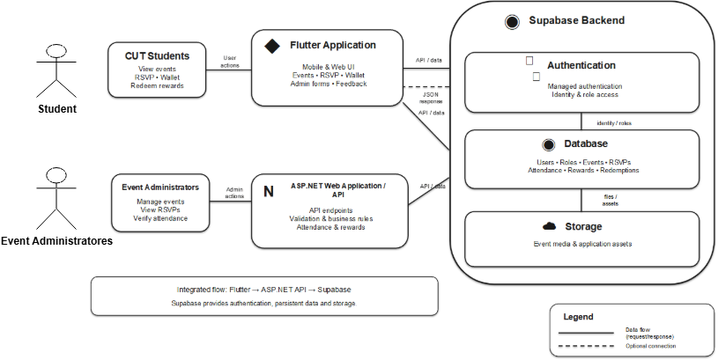

Figure 1: Proposed Campus Coupon System Architecture

Explanation of the Architecture (6th Step)
Question | Architecture Explanation
1. Who uses the Flutter application? | CUT students use the Flutter application to log in, view campus events, RSVP, view their reward wallet and transaction history, and use eligible rewards. Event administrators also use the Flutter interface for event management, RSVP-list viewing and attendance verification. The Flutter client provides the crossplatform mobile/web user interface.
2. Who uses the ASP.NET application? | The ASP.NET application/API primarily serves the Flutter clients rather than being a separate end-user interface. It processes requests from students and administrators, validates requests, applies business rules, and coordinates events, RSVPs, attendance, rewards and redemption processes.
3. What is Supabase responsible for? | Supabase provides backend services for managed authentication, persistent database storage and storage of application media/assets where required. The database stores users, roles, events, RSVPs, attendance and reward/redemption transactions. Authentication supports identity and role-based access control.
4. How does Flutter communicate with Supabase? | The SRS allows Flutter to interact with Supabase where the architecture requires direct supported interaction. In the main integrated flow, Flutter sends application requests to the ASP.NET API, while Supabase provides the backend services used by the solution
5. How does ASP.NET communicate with Supabase? | ASP.NET communicates with Supabase for persistent backend access. It uses Supabase services to work with authentication, database records and required stored assets. ASP.NET applies validation and business rules before
 | coordinating changes to events, RSVPs, attendance, rewards, wallets and redemption records.
6. How do the two applications form one integrated solution? | Flutter provides the presentation and user-interaction layer, while ASP.NET provides application/API and business-logic services. Supabase provides shared backend services and persistent data. Together they form one integrated system in which user actions are processed through the application services and the resulting data is securely stored and retrieved from the shared backend.

Architecture Summary
Overall, the proposed architecture separates the user interface, application/business services and backend services. Students and administrators interact through Flutter, ASP.NET controls application processing and business rules, and Supabase provides authentication, persistent data and storage. This allows the mobile and web interfaces to operate as one Campus Coupon solution while maintaining clear responsibilities between components.

